- PRIORITY (PRE-EMPTIVE)

#include <stdio.h>
int main()
{
int n;
printf("Enter number of processes: ");
scanf("%d",&n);

int pid[n], at[n], bt[n], pr[n];
int rt[n], ct[n], tat[n], wt[n];

for(int i=0;i<n;i++)
{
printf("Enter Process ID, Arrival Time, Burst Time, Priority: ");
scanf("%d%d%d%d",&pid[i],&at[i],&bt[i],&pr[i]);
rt[i] = bt[i];
}

int current_time = 0, completed = 0;

while(completed < n)
{
int selected = -1;

for(int i=0;i<n;i++)
{
if(at[i] <= current_time && rt[i] > 0)
{
if(selected == -1 || pr[i] < pr[selected])
{
selected = i;
}
}
}

if(selected == -1)
{
current_time++;
}
else
{
rt[selected]--;
current_time++;

if(rt[selected] == 0)
{
ct[selected] = current_time;
tat[selected] = ct[selected] - at[selected];
wt[selected] = tat[selected] - bt[selected];
completed++;
}
}
}

printf("\nPID\tAT\tBT\tPR\tCT\tWT\tTAT\n");

for(int i=0;i<n;i++)
printf("%d\t%d\t%d\t%d\t%d\t%d\t%d\n",
pid[i],at[i],bt[i],pr[i],ct[i],wt[i],tat[i]);

return 0;
}
OUTPUT :
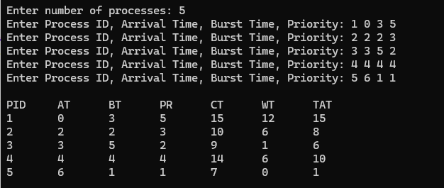

- PRIORITY(NON-PREEMPTIVE)

#include <stdio.h>

int main()
{
int n;
printf("Enter number of processes: ");
scanf("%d",&n);

int pid[n], at[n], bt[n], pr[n];
int ct[n], tat[n], wt[n];
int completed[n];

for(int i=0;i<n;i++)
{
printf("Enter Process ID, Arrival Time, Burst Time, Priority: ");
scanf("%d%d%d%d",&pid[i],&at[i],&bt[i],&pr[i]);
completed[i] = 0;
}

int current_time = 0, completed_count = 0;

while(completed_count < n)
{
int selected = -1;

for(int i=0;i<n;i++)
{
if(at[i] <= current_time && completed[i] == 0)
{
if(selected == -1 || pr[i] < pr[selected])
{
selected = i;
}
}
}

if(selected == -1)
{
current_time++;
}
else
{
ct[selected] = current_time + bt[selected];
tat[selected] = ct[selected] - at[selected];
wt[selected] = tat[selected] - bt[selected];

current_time = ct[selected];

completed[selected] = 1;
completed_count++;
}
}

printf("\nPID\tAT\tBT\tPR\tCT\tWT\tTAT\n");

for(int i=0;i<n;i++)
printf("%d\t%d\t%d\t%d\t%d\t%d\t%d\n",
pid[i],at[i],bt[i],pr[i],ct[i],wt[i],tat[i]);

return 0;
}

OUTPUT :
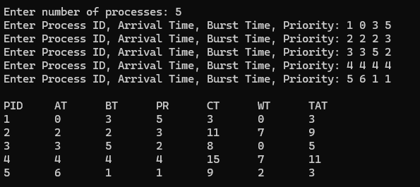

- ROUND ROBIN
#include <stdio.h>

int main()
{
int n, tq;

printf("Enter number of processes: ");
scanf("%d",&n);

printf("Enter Time Quantum: ");
scanf("%d",&tq);

int at[n], bt[n], rt[n];
int ct[n], tat[n], wt[n], response[n];
int visited[n];

printf("Enter arrival times:\n");
for(int i=0;i<n;i++)
scanf("%d",&at[i]);

printf("Enter burst times:\n");
for(int i=0;i<n;i++)
{
scanf("%d",&bt[i]);
rt[i] = bt[i];
visited[i] = 0;
response[i] = -1;
}

int queue[100];
int front = 0, rear = 0;

int time = 0, completed = 0;

queue[rear++] = 0;
visited[0] = 1;

while(completed < n)
{
int i = queue[front++];

if(response[i] == -1)
response[i] = time - at[i];

if(rt[i] > tq)
{
time += tq;
rt[i] -= tq;
}
else
{
time += rt[i];
rt[i] = 0;

ct[i] = time;
tat[i] = ct[i] - at[i];
wt[i] = tat[i] - bt[i];

completed++;
}

for(int j=0;j<n;j++)
{
if(at[j] <= time && visited[j]==0)
{
queue[rear++] = j;
visited[j] = 1;
}
}

if(rt[i] > 0)
queue[rear++] = i;

if(front == rear)
{
for(int j=0;j<n;j++)
{
if(visited[j]==0)
{
queue[rear++] = j;
visited[j] = 1;
break;
}
}
}
}

float avgwt=0,avgtat=0;

printf("\nRRS scheduling:\n");
printf("PID\tAT\tBT\tCT\tTAT\tWT\tRT\n");

for(int i=0;i<n;i++)
{
printf("%d\t%d\t%d\t%d\t%d\t%d\t%d\n",
i+1,at[i],bt[i],ct[i],tat[i],wt[i],response[i]);

avgwt += wt[i];
avgtat += tat[i];
}

printf("\nAverage turnaround time: %.6f\n",avgtat/n);
printf("Average waiting time: %.6f\n",avgwt/n);

return 0;
}

OUTPUT :
